Experiment No. 1
Create a Kanban Board to Visualize the Tasks using Jira Software

Aim
The objective of this experiment is to create a Kanban Board using Jira Software, add sample tasks, and simulate a software development workflow by moving tasks through different stages such as To Do, In Progress, and Done.

Software Requirements
Software | Version
Jira Cloud | Web Application
Web Browser | Google Chrome / Microsoft Edge
Internet Connection | Required

Theory
Jira is a popular project management and issue tracking tool used by software development teams to plan, monitor, and manage projects.
A Kanban Board is a visual workflow board that organizes work into columns representing different stages of development. Team members move tasks from one column to another as work progresses. Kanban improves visibility, reduces bottlenecks, and helps teams focus on ongoing work.
In software engineering, Kanban is widely used because it supports continuous delivery, improves collaboration, simplifies task tracking, and enables project managers to monitor progress in real time. It is easy to understand and suitable for agile development practices.

Procedure
Step 1
Open a web browser on your system.
Navigate to the Jira Cloud website by entering its URL in the address bar.
Sign in using your registered Jira account credentials.
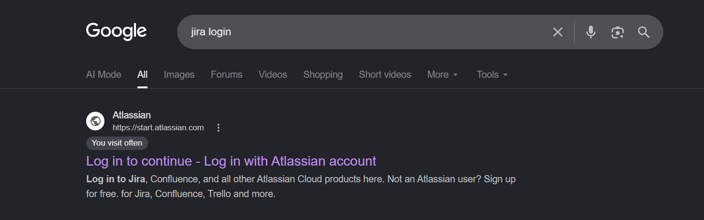
Figure 1. Opening Jira Cloud.
Step 2
After logging in successfully, click the "Jira" option available in the left navigation panel.
This action opens the main Jira workspace where projects and boards can be managed.
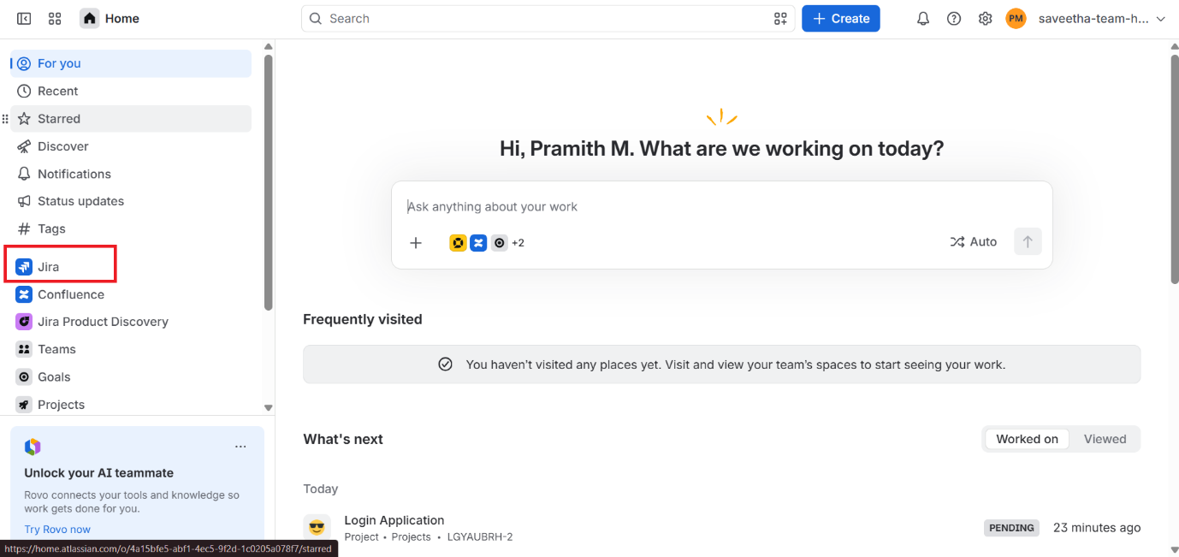
Figure 2. Opening Jira Workspace.
Step 3
Click the "Create Space" button located within the Jira workspace to begin creating a new project space.
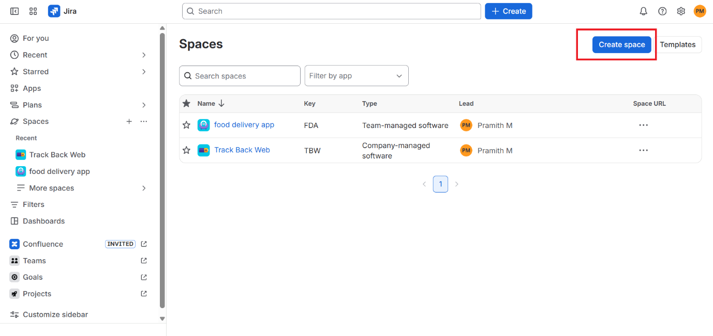
Figure 3. Creating a New Space.
Step 4
Under the Category option, select Software Development.
Select the Kanban Template from the list of available templates.
Click the Next button to proceed.
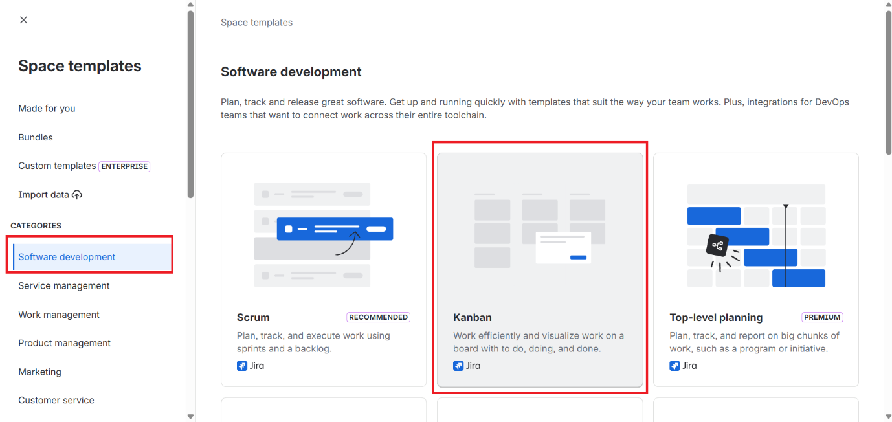
Figure 4. Selecting the Kanban Template.
Step 5
Enter the project Name as "Student Task Management System".
Choose the Management Type as Company-managed.
Enter the project Key as "STMS".
Click the Next button to complete the space setup.
Screenshot Placeholder
Figure 5. Entering Space Details.
Step 6
The Kanban Board is created successfully and displayed on the screen.
The board contains the following workflow columns:
- Backlog
- Selected for Development
- In Progress
- Done
The Backlog column holds tasks that are yet to be started. Selected for Development contains tasks chosen for the current cycle. In Progress represents tasks currently being worked on, and Done contains completed tasks.
Screenshot Placeholder
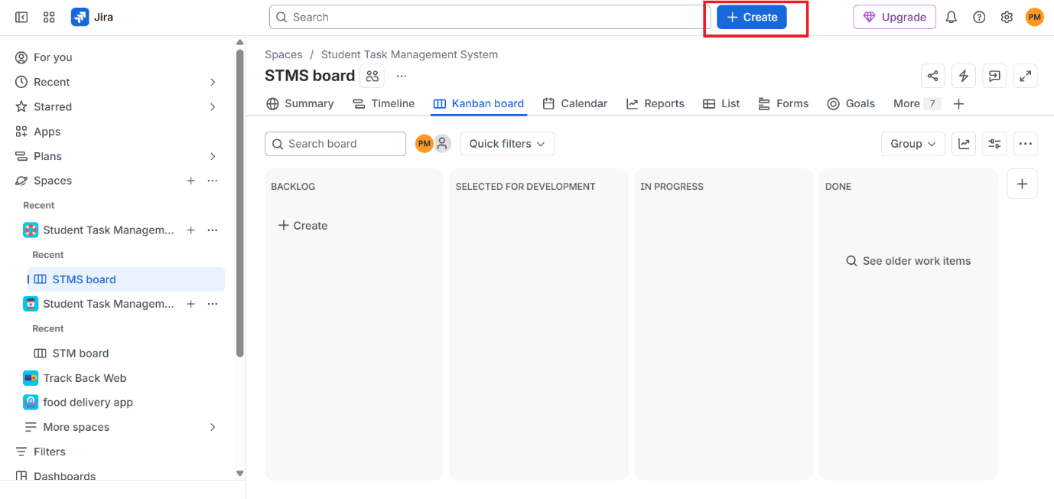
Figure 6. Newly Created Kanban Board.
Step 7
Click the Create button to add new tasks to the board.
Add the following five sample tasks as listed in the table below.
Task ID | Task Name | Description
STM-1 | Gather Project Requirements | Collect functional and non-functional requirements.
STM-2 | Design Login Page | Design the login user interface.
STM-3 | Develop Database | Create database tables and relationships.
STM-4 | Implement User Authentication | Develop login and registration functionality.
STM-5 | Testing and Bug Fixing | Test the application and fix defects.

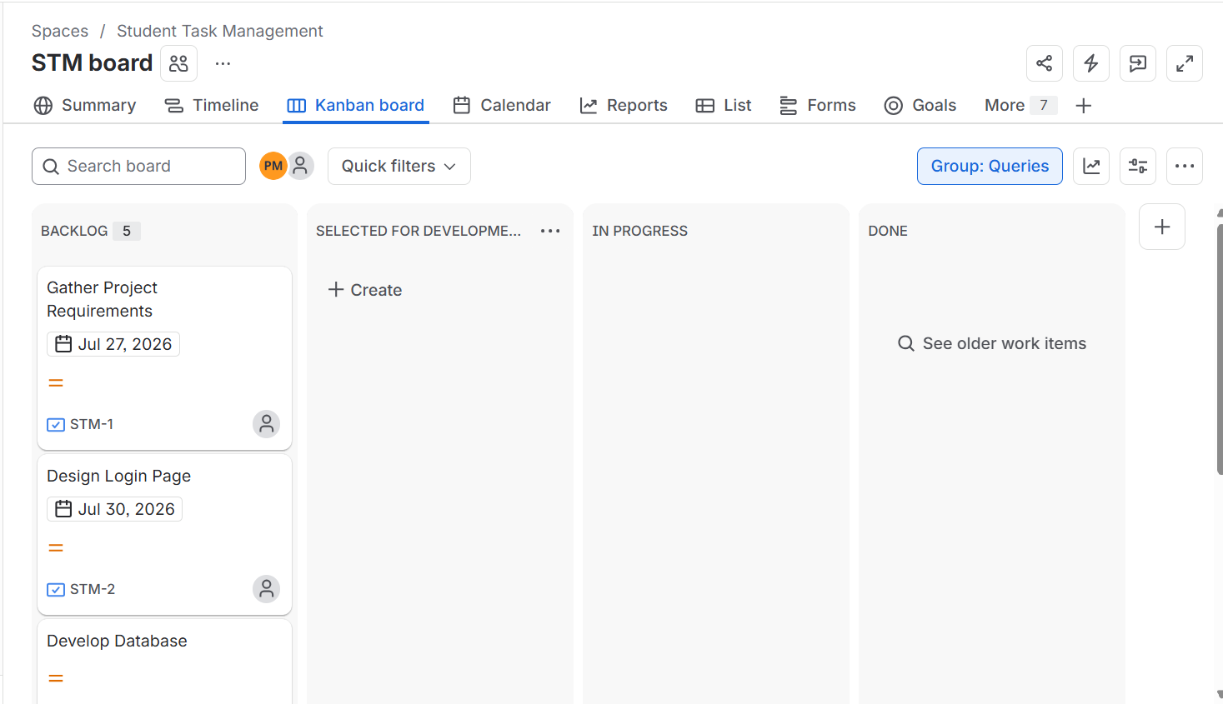
Figure 7. Creating Sample Tasks.
Step 8
Move the tasks across the different workflow stages by dragging and dropping them between columns, as shown below:
Gather Project Requirements: Backlog → Selected for Development → In Progress → Done
Design Login Page: Backlog → In Progress → Done
Develop Database: Backlog → In Progress
Testing and Bug Fixing: Selected for Development

Moving issues across the board represents the actual progress of tasks during the software development process, allowing the entire team to visually track project status at any point in time.
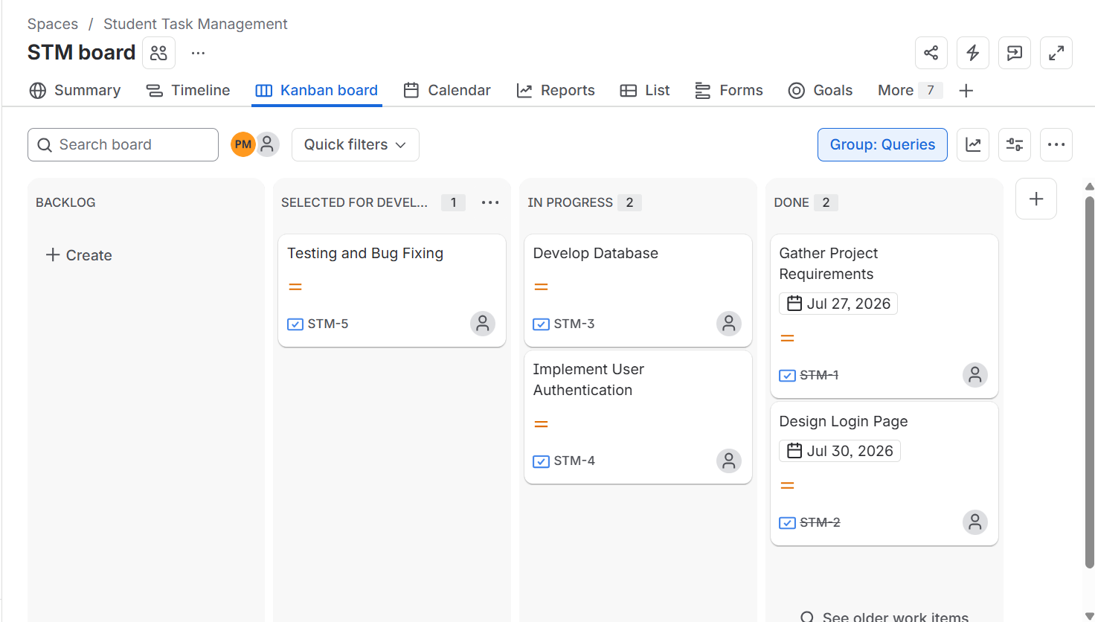
Figure 8. Moving Tasks Across Workflow Stages.

Observation
Task Name | Initial Status | Final Status
Gather Project Requirements | Backlog | Done
Design Login Page | Backlog | Done
Develop Database | Backlog | In Progress
Implement User Authentication | Backlog | Backlog
Testing and Bug Fixing | Backlog | Selected for Development

Result
The Kanban Board was successfully created using Jira Software. Five sample tasks were added and moved across different workflow stages to simulate a software development process. The experiment demonstrated how Jira helps teams visualize, organize, and track project progress efficiently.

